WHAT’S ON?

Week 7

Mon – Frid | ▪ Balgownie Book Week
Mon – Thur | ▪ Book Fair in Library  3.00 – 3.30pm
Thur 1.9.11 | ▪ Book Week Dress Up,  Performance and Lunch
 | ▪ Music Count Us In
 | ▪ Start of Silver September
Fri 2.9.11 | ▪ Regional Athletics Carnival

Week 8

Fri 9.9.11 | ▪ Gala Day - Boys Dragon Tag  Girls AFL

Lights, cameras action! What a fabulous week last week with Southern Stars. It was a sensational show and I am always amazed by the talents of students and staff in Public Education. Our own Poppy Adams and Tanya Storey were in major parts as well as our fabulous Mary Poppins chimney sweep dancers and wonderful choir. The show was a hit! Thanks to Ms Main, Mrs Hockey, Mrs Carrigan Mrs Shum and Mrs Lewis, the team back at school and all those who helped with sewing, props, transport and organisation.

Citizenship alive and well Thanks to the team of hard working kids and Mr McGoldrick on Friday and Mrs Burns on Tuesday who have mulched the gardens. It looks so much better and the values of responsibility have been demonstrated by your hard work and citizenship.

31/8/11

TERM 3 - WEEK 7

Book Week celebrations Thanks to Mrs Birchall for her organisation of Book Week. Come on Thursday ready for some fun with our Book Parade of most loved characters from ‘Around the World.” Don’t forget the book fair in the library. Christmas is just around the corner……..

Good luck to our Bally Boys who are playing in the final of the Illawarra South East Region on Thursday at 11am. The Region goes from Helensburgh to the Victorian border and out west as far as Yass and included Queanbeyan and Southern Highlands.

Reading, Writing and Arithmetic.
It is National Literacy and Numeracy week. The site http://www.nlnw.nsw.edu.au/index.htm has some fabulous ideas for kids, and also for parents, to support learning at home. There are some audio files that you can download to help you link everyday activities with student learning. There are also some links to wonderful student sites etc. Have a look and save it on your favourites!!

Have Your Say Our hardworking Grounds and Environment Committee (and Mrs Burns) have put together a survey that is attached in this newsletter. The results of this will be discussed at the next P and C meeting. Completed surveys with names will go into the draw for a $50 voucher from Woolies.

Working together to ‘build better kids’. We have become members of Parenting Ideas from Michael Grose. His motto is ‘Raising kids to thrive. Confidence. Character. Resilience.’ At times you will see relevant articles by Michael in the newsletter. We are currently uploading the blog onto our website with parenting hints and tips. While we are ironing out the last technical difficulties, Mr Loxton is uploading current articles as they arrive (thanks Mr Loxton). This week is about Father’s Day. I have enclosed an excerpt for you. If you want to read the entire article then it’s on our website.

Thought of the Week
Books are the quietist and most constant of friends; they are the most accessible and wisest of counsellors, and the most patient of teachers. Charles W Eliot

Building up frequent father points
One way to build better relationships is for dads to build plenty of frequent father points when kids are young. Here’s how to go about it.

A good friend enthusiastically told me how he just spent a few days away on his own with his two kids, aged 10 and 13. He was feeling quite chuffed.
He had some ‘dad time’ with his kids.
Good on him!

He was doing some memory-building & relationship-building, as well as having some fun. He told me that he was aware that his kids were getting older and he knew such opportunities were diminishing……(on the website)

To all the dads, stepdads and grandpas out there, Happy Fathers Day for Sunday. I hope your brekkie in bed, your day out fishing with the kids or the BBQ that you will be going to is full of love and laughter.
Thanks also to the parents who have organised the stall and who have been busily wrapping today!!

Have a great week,
Aloma Stewart

Joke of the Week
Why did the elephant sit on the marshmallow?
So he wouldn't fall in the hot chocolate.

STEWART HOUSE CLOTHING APPEAL 2011
Stewart House clothing appeal bags will be sent home with the children this week. Please return bags to the old school hall by Tuesday 6th September, for collection by Stewart House.

SOUTHERN STARS
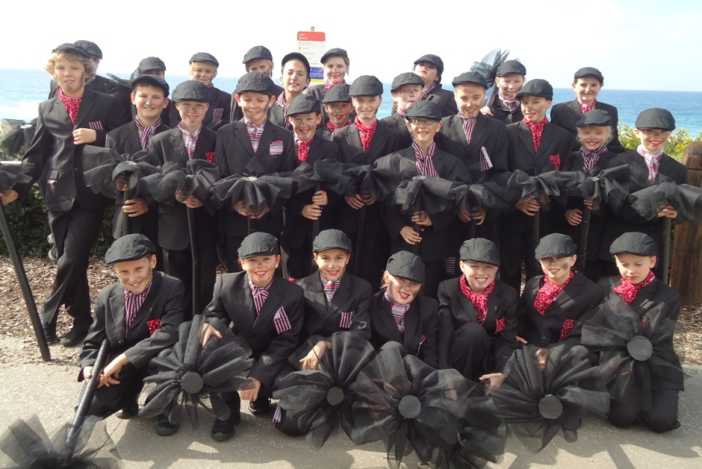

Congratulations to all the students who danced, sang and acted in Southern Stars last week. The performances were amazing and your behaviour was outstanding. Be proud of yourselves…you deserve it!
Well done boys and girls. We’re very proud of you.

CANTEEN ROSTER

Week 8, Term 3

♦ The Canteen is now open every day

Day | Date | Name
Mon | 5.9.11 | Meikell McCreadie  Yuki Nakamura-Bell
Tues | 6.9.11 | Janette Pickham  Marion Payne
Wed | 7.9.11 | Elissa Kohler  Lisa Tunstall
Thurs | 8.9.11 | Martha Newman  Greg Abernethy
Fri | 9.9.11 | Bev Critcher  Sharyn Ross

WEEKLY P&C NEWS
For this week’s P&C news please read the accompanying newsletter or view the P&C page on the schools website. Alternatively you can visit the Balgownie PS P&C website www.balgowniepnc.com

CLOTHING POOL
The Clothing Pool is open on
WEDNESDAY mornings from
8.30am each week.
Clothing pool order forms are available on the Balgownie School website & P&C website.

COMMUNITY NEWS

BALGOWNIE PUBLIC SCHOOL MUSEUM

MILO in2CRICKET – Balgownie Cricket Club
The MILO in2CRICKET Program is Cricket Australia’s entry level cricket program, run through the Balgownie Cricket Club, providing an introduction to cricket in a fun, safe, learning environment. Girls and boys can develop their cricket skills, play games and meet new friends.
MILO in2CRICKET runs for 10 weeks before Christmas on Saturday mornings from 8.30am to 10.00am. Every child receives a starter backpack. If your child is interested please see Samantha Wearing or call 0414646244.

FAIRY MEADOW JUNIOR SURF CLUB
2011/2012 NIPPER REGISTRATION
Sunday 11th September 11
Sunday 25th September 11
At Fairy Meadow Surf Club Function Room
10.00am to 2.00pm
All new & old members welcome to attend
Telephone: Scott 4283 7558

Please note that the Museum will not be open on Sunday
4th September. Next open day will be Sunday 2nd October,
1.00 – 4.00pm.

