WHAT’S ON?

Week 8

Thur 8.9.11 | ▪ Industrial Action
Fri 9.9.11 | ▪ Gala Day - Boys Dragon Tag  - Girls AFL

Week 9

Wed 14.9.11 | ▪ P&C Meeting 7.15pm
Frid 16.9.11 | ▪ Spelling Bee – Fairy Meadow Dem School

What a wonderful week! Book Parade, Regional Athletics and our boys soccer team are Illawarra South East Regional Champions! This is apart from the community involvement and the super learning in the classrooms. Balgownie is a unique school where community and school really come together to make this a fabulous centre for learning, both in classrooms and in whole school events.

Firstly may I personally congratulate the Balgownie Boys on their soccer win against a quality opposition. Vincentia team played well and their outstanding goalie saved numerous attempts. Our team played hard and fair, and were rewarded for their efforts with a 4-0 win. We are the champions! Mr Terry was cool, calm and collected and the sideline support was warm, fair and maybe not quite so calm!! (It was an exciting match!) I was so proud of being part of this event.

To then return to school and smell the sausages sizzling and the excitement buzzing of the Book Parade made Thursday a special day. See the attached article by Jelena
and Dana about this event. We all value learning to read as a vital life skill and understand the implications when someone finds reading difficult. It is lovely to celebrate books and the fun we can have with this world of literature. To share a good story with someone is something that all

7/9/11

TERM 3 - WEEK 8

cultures do, both verbally or in writing, and of course now, visual media is an increasing part of our literary world.

The message given to our students through the support of parents and carers who had made costumes, those who attended the celebration, teachers who organised items and those who dressed up in costume, was that reading important and fun. Congratulations to B1 and B2 who won the staff dress up prize. The student leaders picked the winners out of a very tight contest.

Thanks everyone for making the event a success and especially to Mrs Birchall for being brave enough to come as Captain Underpants as well as organising a smashing event!

When you thought the week could not get any better, our fastest and strongest athletes competed as part of our Brokers Team at the regional Athletics Carnival in Queanbeyan. Congratulations to Charlotte Gaynor, Tamsyn Peel, Lara Webster, Wesley Van Kempen, Lachlan Cohen, Travis Effting, Cooper Buswell, Lucy Van Ryn, Jelena Zelkovic, Luke Moss, Joel Willis, Lachlan Konza, Boys and Girls 8-10 relay teams and Boys 11-13 relay team.

Some notable results include:
- Lachlan Konza 1st in Discus with a new record of 37.81metres. He now holds multiple South Coast records in a variety of age groups. Well done Lachlan!
- Joel Willis 4th in the Long Jump
- Wesley Van Kempen 5th in 800 metres.

Great job everyone and Lachlan now progresses up to the next level of competition as part of the Regional team. Congratulations Lachlan!

The P and C will be launching the Fun Run/ Walkathon next week. Stay tuned for this. Lets promote healthy lifestyles while raising some money for the school.

Don’t forget to have your say on the School grounds survey and drop your responses into the canteen. You could be in the running for a $50 gift voucher to spend at Woolies!

Thought of the Week
How far you go in life depends on your being tender with the young, compassionate with the aged, sympathetic with the striving, and tolerant with the weak and the strong. Because someday in your life you will have been all of those. George Washington Carver.

Have a great week,
Aloma Stewart

Joke of the Week
You're in a haunted house and you come to 3 different doors. Behind the first door there is poisonous spiders, behind the second door there is poisonous snakes. Behind the last door there are alligators who haven't eaten in a year. What door should you open?
Open the third door. The alligators are dead because they haven't eaten in three years.

BOOK WEEK
A big thank you to the entire school community for supporting all of our book week activities for 2011.
Thank you to everyone who came in fancy dress for the parade and congratulations to B1 and B2, who were voted best dressed in the teacher competition. Don’t forget to look out for the Book Week photo album coming soon to your favourite library.

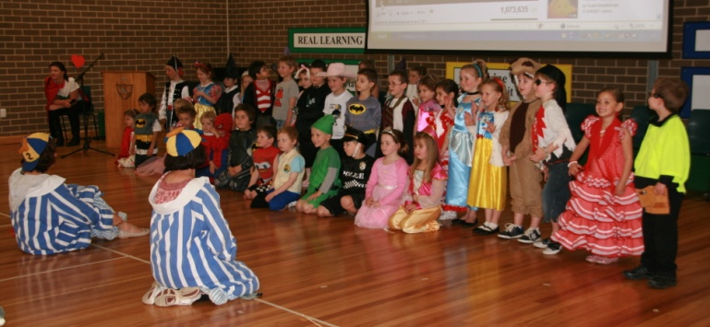

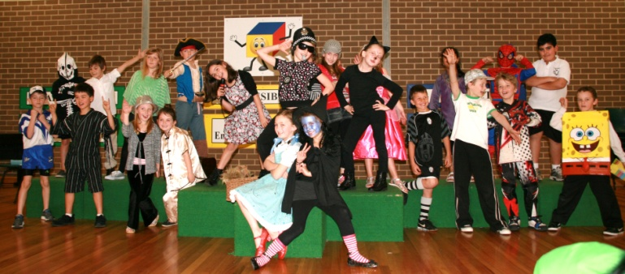

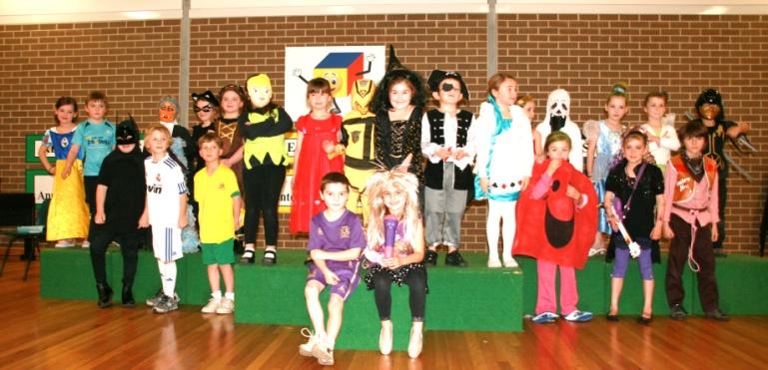

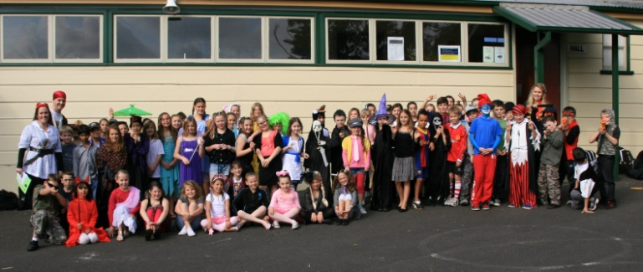

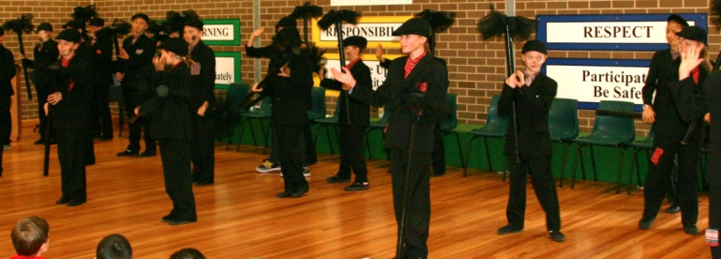

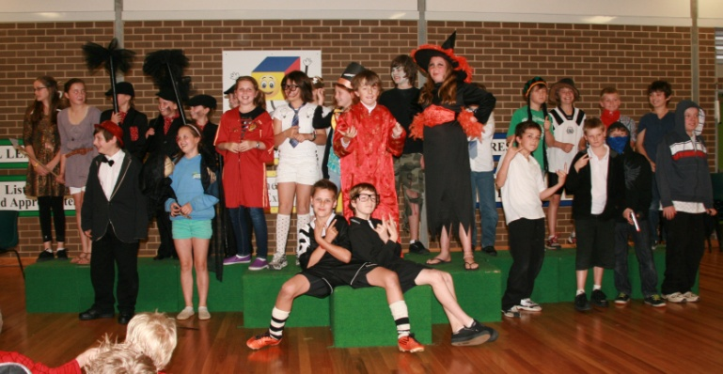

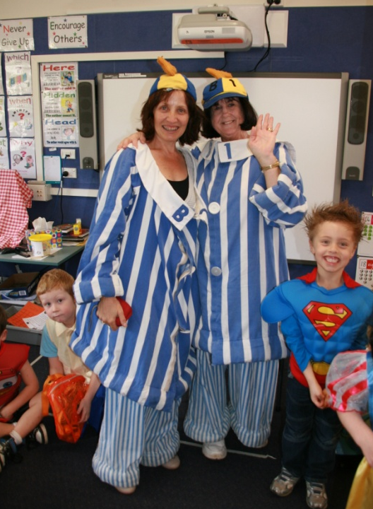

B1 & B2

BOOK PARADE
As most of you know, last week our school held the 2011 book week parade. Our theme this year was One World, Many Stories, so students were asked to come as either their favourite book character or wear an outfit representing a different country. Costumes ranged from fairy princesses to children dressed in kimonos.

During the parade we were entertained thoroughly by musical items and speeches. One of the musical items included our school singing "We've Got The Music" at the same time as 3000 other students across the country. After the parade parents were invited to enjoy a picnic lunch with their children. Also a big thanks to Mrs Birchall to all the hours of hard work she put into this to make Book Week possible. Overall it was a great success and a lovely experience.

By Jelena Zeljkovic and Dana Behan

COLES SPORT FOR SCHOOLS
Great effort by people bringing in vouchers from Coles. We now have a total of 4,100 vouchers. Keep collecting, every voucher counts!
Mrs Kerema

SOUTH COAST PRIMARY SCHOOLS BOY’S FOOTBALL FINAL
Congratulations to our Balgownie P.S Boy’s Football Team who last Thursday, (01/09/11), won the PSSA South Coast Boy’s Football Championship after defeating Vincentia P.S. The final was played on home turf at Judy Masters Oval in Balgownie and from the
outset; our boys looked up for the job! After dominating
early possession, Wesley Van- Kempen shot from wide out to score our first goal and take an early lead. The score remained this way until half- time, much due to the efforts of Vincentia P.S’s goalkeeper who produced a number of outstanding saves to thwart our goal- bound efforts.

Frustratingly, Balgownie P.S couldn’t convert numerous
chances throughout the second half until finally our efforts were rewarded with late goals to Joel Willis, Jonathan Wilson and Cooper Buswell. These goals sealed the match for Balgownie and when the final whistle blew, the team was crowned South Coast Champions for 2011. A big effort from the defensive quartet and also the midfield maestros in our team who played outstandingly all game! Mr McGoldrick reports this is the first football team from Balgownie P.S in quite a while to win a South Coast title and adds to Balgownie P.S’s rich footballing tradition.

The boys now move onto the NSW State Quarter Finals where they will play either Hanwood P.S from the
Riverina region or Harbord P.S from Sydney’s Northern Beaches. This is a great achievement from the team and they must be congratulated for their fine efforts! A big thank you once again to parents for their continued support in transporting students, setting up grounds and warming players up, your help is much appreciated!

Best of luck to Cooper Buswell, who this week is playing in the Australian Primary School Football Championships in Canberra. Cooper is representing NSW Primary School’s at the Championships and when results come to hand next week, a full report of his team’s participation and results will be detailed.
Mr Terry

CANTEEN NEWS - IMPORTANT NOTICE
Canteen will be CLOSED on THURSDAY, the 8th of September
Due to the teacher's strike planned for this THURSDAY, the 8th of Sep, THE CANTEEN WILL BE CLOSED for all services. Parents and carers need to arrange food if your children need to attend school on this day.
Thank you.

CANTEEN ROSTER

Week 9, Term 3

Day | Date | Name
Mon | 12.9.11 | Deb Burford  Joanne Holland  Cindy Burton-Woods
Tues | 13.9.11 | Callie Heyman  Julie Clark
Wed | 14.9.11 | Jenny McConchie  Sam Halmay  Jade Firth
Thurs | 15.9.11 | Mary Papakosmas  Mandy Fanning
Fri | 16.9.11 | Tahnee Lowe  Amanda Baulman  Louise Lelliot

CLOTHING POOL
The Clothing Pool is open on
WEDNESDAY mornings from
8.30am each week.
Clothing pool order forms are available on the Balgownie School website & P&C website.

GROUNDS & ENVIRONMENT SUBCOMMITTEE
Win a $50 Woolworths voucher!!

Don’t forget to fill out our Schoolgrounds Survey that was sent out with last week’s newsletter. Returned surveys with names and contact numbers on them will go in the draw for a $50 Woolworths gift voucher. We’re interested in hearing your ideas about how our schoolgrounds can be improved so please return your survey to the canteen slot by Monday, September 12.

COMMUNITY NEWS

MILO in2CRICKET – Balgownie Cricket Club
The MILO in2CRICKET Program is Cricket Australia’s entry level cricket program, run through the Balgownie Cricket Club, providing an introduction to cricket in a fun, safe, learning environment. Girls and boys can develop their cricket skills, play games and meet new friends.
MILO in2CRICKET runs for 10 weeks before Christmas on Saturday mornings from 8.30am to 10.00am. Every child receives a starter backpack. If your child is interested please see Samantha Wearing or call 0414646244.

BALGOWNIE PUBLIC SCHOOL COMMUNITY PLAYGROUP
If you have a child starting kindergarten in 2012 and would like to meet other carers and their children who will be starting next year at Balgownie Public School we would love to meet you!

Meet and Greet in the Park
Please join us:
Thursday 15th September 2011
9.30am – 11.00am
At the children’s playground at Guest Park, Fairy Meadow (or wet weather option Little Stompers, Fairy Meadow).
If it is a sunny day, bring along a picnic for morning tea.
For further details please contact:
Donna Guest 0447790619
Toni Lea-Howie 0438325853
Kate Smith 0427567550

